(Approx. 1370 words)

Learning to Program
By Dick Maybach, Member, Brookdale Computer Users’ Group, NJ
February 2015 issue, BUG Bytes
www.bcug.com
n2nd (at) att.net

If you are interested in learning about programming, or you'd like to introduce a young person to it, how do you begin? Clearly, the approach would differ for an eight-year-old who wants to design a game, for an adult who is curious about how software works, or for a student considering a computer science major in college. You can't learn programming by approaching it as an abstract concept. Instead you have to come down to earth and wrestle with real code, and this means you first have to pick a programming language. With hundreds to choose from, this can be difficult. However, if you have a particular application in mind, the choice is easier. For example, if you want to code extensions to Excel, you will probably choose Visual Basic. Suppose though this isn't the case, what characteristics should you look for in your first language?

- It should be simple enough that you can begin writing programs without wading through hundreds of pages of text.
- It should run on a wide variety of computer hardware and operating systems.
- There should be good tutorials for it.
- It should have a useful development environment that is a set of software to assist you in coding, debugging, and running your programs.
- There should be a forum (probably on a Website) where you can ask questions and find example programs.
- It should encourage writing clean, well-structured code. (The most notorious violators of this were early implementations of BASIC and FORTRAN, which were infested with the infamous "goto" statement to move to different points in their programs.)
I propose that you consider three languages, Scratch, Python, and modern variants of BASIC - Scratch for young people, the typing-challenged, and those with only a casual interest in programming, Python for almost everyone else, and a BASIC variant if you have a specific application that uses it or if you're interested in reliving your early PC experiences. I have no experience with it, but you might also consider Java, which is used for both PC applications and on Websites.

Scratch, http://scratch.mit.edu/, is unusual in that, unlike any other language, it doesn't require typing skill. Instead, creating a program in Scratch involves moving shapes (representing commands) together to form a program. The physical act is much like assembling a jigsaw puzzle. As a result, someone can concentrate on the logic of a program rather than on the mechanics of assembling a command sequence. The downside is that except for the concepts of composing a set of instructions into a logical structure, there is little that you will learn that can be applied to other languages. Scratch was developed by the MIT Media Lab to introduce students, teachers, and parents to programming and to provide a stepping stone to more advanced languages. It can be run on-line using a browser or as a local application on your PC.
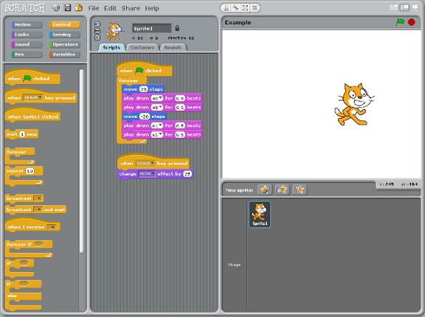
In the screen-shot of the Scratch development environment, the program is assembled in the center column by dragging command icons from the left column. (The contents of the left panel change depending on what class of commands is selected at the top of the column.) The top panel in the right column (called the stage) is where the program runs. In the simple case shown, the program starts when you click on the green flag at the upper right and loops continuously. The cat icon (which Scratch calls a sprite) moves 20 steps ahead; a drum beats twice, the cat moves 20 steps back; a different drum beats twice; and this repeats. A second routine below the main program results in the sprite changing color each time you press the space bar. The bottom panel in the right column is where you change the sprite, its costume, and the stage background.
While Scratch is clearly not suited to data crunching, it can be used for surprisingly complex games and animations. That it doesn't require typing means that even young children can learn logic and the basis of programming. Its downside is that it's a dead end, since except for encouraging logical thinking it doesn't provide a path to other programming environments. However, the skills it does help develop are invaluable and shouldn't be overlooked. For more information, see Scratch 2.0 Programming for Teens, by Jerry Lee Ford, Jr., or make a Web search for “scratch language.”

Python is a modern programming language, suitable both for learning the craft and working at a professional level. As a result it's a good choice for a range of users, from the casual hobbyist through someone who is considering a career in programming. When you begin learning Python, you will probably use it within the Idle Development Environment, which facilitates editing, debugging, and running programs. Idle has two windows – one for editing the program and one for running it. In the screen-shot, the program runs in the left window, called the shell, and you edit code in the one on the right.
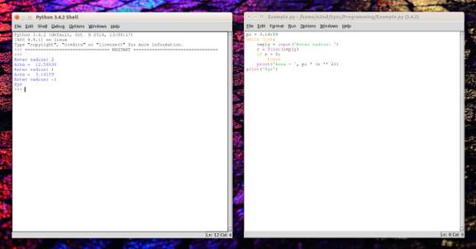
The simple program shown calculates the area of a circle with a given radius. As you can see from the shell window and perhaps from the code, it asks you to enter the radius, prints the area, and repeats until you enter a negative number. If you are familiar with the c language or its variants, you have probably noted that Python is significantly simpler. In particular, it doesn't require you to declare variables; in the example it understands that pi and r are floating point quantities and that reply is a string.

It is probably not evident, but being able simultaneously to see both the code and its result is a very useful while learning. For example, to understand a new command, you can enter an example of its use in the shell and see immediately what it does.

Python is widely used to code application programs and on Websites. It can be approached casually, at a level not much advanced over Scratch, or with as much rigor as you can tolerate. It supports complex data and object-oriented code structures, and as a result is often used in college programming courses. Because it originated relative recently, it takes advantage of the experiences of older languages and eliminates many of their short-comings. Good books on Python are Python for Kids, by Jason R. Briggs (where the examples are graphics and games, much like those for Scratch), Learn Python the Hard Way, by Zed A. Shaw (which is a fairly easy read with many examples and exercises), and Learning Python, by Mark Lutz (which, at 1500 pages is not for the faint of heart, but is well written and essential if you are serious about doing some real work with the language).

When personal computers first appeared, almost every one of them had a BASIC interpreter. Unfortunately, the early versions of the language had significant shortcomings that encouraged bad programming habits. Since then, there have been many efforts to improve and extend the language, but most of these are niche products. A possible exception is Visual BASIC, which is used to add features to Microsoft Office. As a result, unless you know that a particular variant is important to you, you probably should avoid BASIC as a vehicle to learn programming. However, if you have worked with BASIC in the dim past and would like to renew the acquaintance rather than taking on something completely new, there are some modern, no-cost variants. All of them let you write programs with good structure and provide for graphical output (neither of which was true of the early BASICs). However, their modern features result in languages that have little resemblance to traditional BASIC. Two examples are FreeBASIC, http://www.freebasic.net/, for Windows and Linux, which has a mode that is compatible with QBASIC (if you're old enough to have used that) and Microsoft Small Basic, http://www.smallbasic.com/, for Windows.

Unlike when they first appeared, PCs no longer require programming expertise to be useful. However, it is a useful skill that many find enjoyable, and if you pick an appropriate language and a good book, not difficult to acquire.

